

Unity Quiz Tool Instructions

By Matthew Le Nepveu

# Disclaimer

The following document is aimed to assist users in creating custom-made quizzes using the Unity quiz tool. The instructions assume that the user is working off the following hardware and has the following programs installed:

* Windows 10 Operating System.
* Internet.
* An Internet Browser (eg. Google Chrome, Mozilla Firefox, Microsoft Edge, etc.).
* Unity 2019.1.10f1 or later versions.
* Unity Hub.
* A text editor (eg. Notepad, Notepad++, etc.).

# How to Download

Download the Unity quiz tool using this link by clicking the “Download ZIP” option after clicking the “Clone or download” option: <https://github.com/mattylenepveu/UnityQuizTool>

Once the zip file is downloaded, extract the folder by right clicking on the folder and clicking the “Extract All…” option. From there, the files can be extracted by clicking the “Browse…” button and selecting any destination on your computer. This should extract the project from the zip file and onto your computer.

# Adding Questions to the Quiz

Once downloaded, a build is included in the “Build” folder. The build of the setup quiz is the file titled “QuizTool.exe”. Questions have already been setup, so a quiz should be fully playable with questions on Australian Rules Football (AFL).

To add custom questions, open up the “Questions.txt” text document in a text editor (eg. Notepad, Notepad++, etc.) from the directory “./Build/Resources”. Every odd numbered line (eg. 1, 3, 5, etc.) of the document must list the statement for the quiz, whilst every even numbered line (eg. 2, 4, 6, etc.) list either “t” or “T” stating the statement on the line above is true or the letters “f” or “F” meaning the statement on the line above is false. **No lines can be skipped** as once the line detects an empty line, it will break the program. This means that the text document **must have an even number of lines.** Figure 1 shows an example of how the text document should look:

*Figure 1: A sample text document of how the questions for the quiz tool should be laid out.*

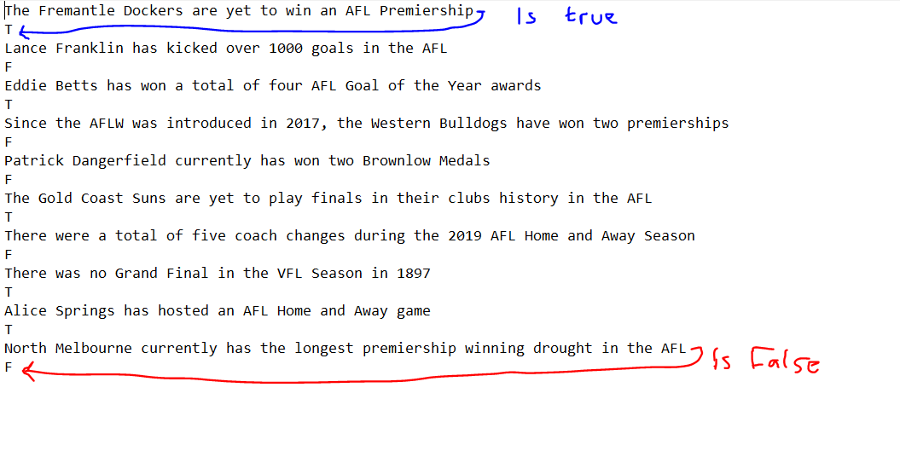

Once questions have been added to the text document, the document **must be saved as “Questions.txt”**, otherwise the quiz will not be able to locate where the questions are and the program will have numerous null reference errors. It also **must not be moved from the “Resources” folder**, as this will cause the same issue is renaming the document.

If every instruction has been followed correctly, the questions should be able to load into the quiz correctly, with the right amount of questions and correct logic being applied to each statement. The questions are randomized and every question should be included before directing the user to the “Results” scene.

# Editing the Project

If users want to edit the main project, the Unity editor can be opened via one of two ways:

1. Opening “Unity Hub” and clicking the “Add” button to add the project. Once the file browser is open, go to the project location and select the folder “QuizTool”. Make sure that to **select Unity Version 2019.1.10f1 or later** is selected in the drop down list.
2. Opening one of the three project scenes by following this directory from the base project folder downloaded: “./QuizTool/Assets/Scenes”. Again, make sure that **Unity Version 2019.1.10f1 or later** is installed before opening, otherwise it may cause errors.

Once the project is opened, all script variables are shown in the inspector when clicked on the following game objects in each scene:

1. For the “Title” scene, click on the “Title Script” game object.
2. If in the “Main Quiz” scene, clink on the “QuizManager” game object.
3. If the “Results” scene is opened, click on the “Results Script” game object.

*Figure 2: A screenshot of the main project with an arrow showing where the inspector should be located.*

